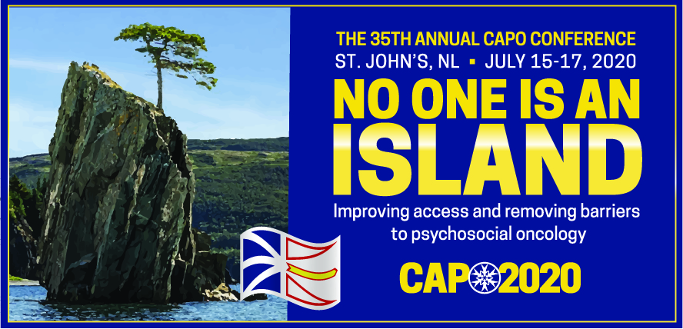

Preconference Workshops: Call for Proposals
Psycho-oncology researchers and clinicians are invited to submit proposals to host
pre-conference workshops.

All workshops will be held from 0830-1200 hrs on Wednesday July 15, 2020.
Workshop proposals are due by December 15, 2019. Submissions are to be sent to conference@capo.ca

Workshop chair(s): name, affiliation
Email(s): click here to enter text
Workshop title: click here to enter text
Target audience: click here to enter text

Workshop description/abstract (max. 200 words):
click here to enter text

Learning objectives:
1. click here to enter text
2. click here to enter text
3. click here to enter text
Length:
☐ half-day

Bio sketch of the chairs (max. 100 words each):
click here to enter text

Please send your preconference Workshop Proposal to conference@capo.ca

CAPO workshop Policies
The conference planning committee recognizes and values the contribution workshop presenters make towards a successful conference, but at the same time also recognize the need to ensure the conference is financially successful for all partners. With this in mind, the 2020 speaker benefits are summarized below.

- Full Conference fees will be waived up to a maximum of two presenters per workshop.
- Workshop presenters are responsible for all other aspects of their participation.

e.g. psychologists, social workers…

