Lentil-Walnut Tacos with Mango Avocado Salsa
Anne Hewitt and Bronwyn Cawker

Preparation Time: 20 minutes
Cooking Time: 30 minutes

Ingredients:

6 servings
Filling
1 ½ cups (230 g) dry brown lentils, rinsed and sorted
1 tbsp (15 ml) olive oil
½ cup (80 g) red onion, finely chopped
4 (12 g) cloves garlic, minced
¼ cup (60 ml) tomato paste
1 tbsp (8 g) cumin
2 tsp oregano
2 tsp (6 g) chili powder
1 tsp (2 g) paprika
1 tsp (3 g) salt
¼ tsp black pepper
Cayenne pepper, to taste
1 tsp (5 ml) red wine vinegar
1 cup (115 g) walnuts, toasted and finely chopped
Mango Avocado Salsa
1 cup (150 g) diced mango
1 (3 g) clove garlic, minced
1 (200 g) avocado, diced
¼ cup (40 g) finely chopped red onion
1 jalapeno (14 g), seeded and finely chopped
1 cup (25 g) cilantro, finely chopped
1 tbsp (5 g) lime zest
3 tbsp (45 mL) lime juice, approx. 1 lime

24 servings
Filling
6 cups (1010 g) dry brown lentils, rinsed and sorted
¼ cup (60 ml) olive oil
2 cups (320 g) red onion, finely chopped
16 (48 g) cloves garlic, minced
1 cup (250 ml) tomato paste
¼ cup (33 g) cumin
8 tsp oregano
8 tsp (20 g) chili powder
4 tsp (7 g) paprika
4 tsp (12 g) salt
1 tsp black pepper
Cayenne pepper, to taste
4 tsp (20 ml) red wine vinegar
4 cups (460 g) walnuts, toasted and finely chopped
Mango Avocado Salsa
4 cups (705 g) diced mango
4 cloves (12 g) garlic, minced
4 (800 g) avocados, diced
1 cup (160 g) finely chopped red onion
4 jalapenos (56 g), seeded and finely chopped
4 cups (100 g) cilantro, finely chopped
¼ cup (20 g) lime zest, approximately 4 limes
¼ cup (60 mL) lime juice, approximately 4 limes

6 6-inch tacos 24 6-inch tacos

Directions
- In medium saucepan, cover lentils with cold water. Bring to a boil, reduce heat and simmer until cooked, about 20 for 6 servings and 30 minutes for 24 servings. Drain and set aside.
- In medium frying pan, heat olive oil over medium heat. Add onion and sauté until translucent, about 5 minutes. Add garlic and sauté until fragrant, about 30 seconds.
- Add tomato paste and spices. Stir well to combine, and cook for 1-2 minutes.
- Add cooked lentils, vinegar, and walnuts and heat through, adding water if necessary to reach desired “taco meat” consistency.
- In a small bowl, combine all ingredients for the salsa. Cover and set aside in the fridge.
- To serve, divide filling between tortillas and top with salsa.

Tips:
- Substitute green, beluga or Puy lentils for the brown lentils, if desired
- To toast walnuts, heat in a dry skillet over medium heat for 2-3 minutes until lightly browned and fragrant. Alternatively, spread nuts on a parchment-lined baking sheet and roast at 350°F (175°C) for 8-10 minutes, stirring occasionally.
- Filling can be made ahead and reheated gently, adding water as necessary.
- Cashew sour cream, extra sprigs of cilantro, your favourite hot sauce, or quick pickled onions are great additional topping options!

Nutritional Information
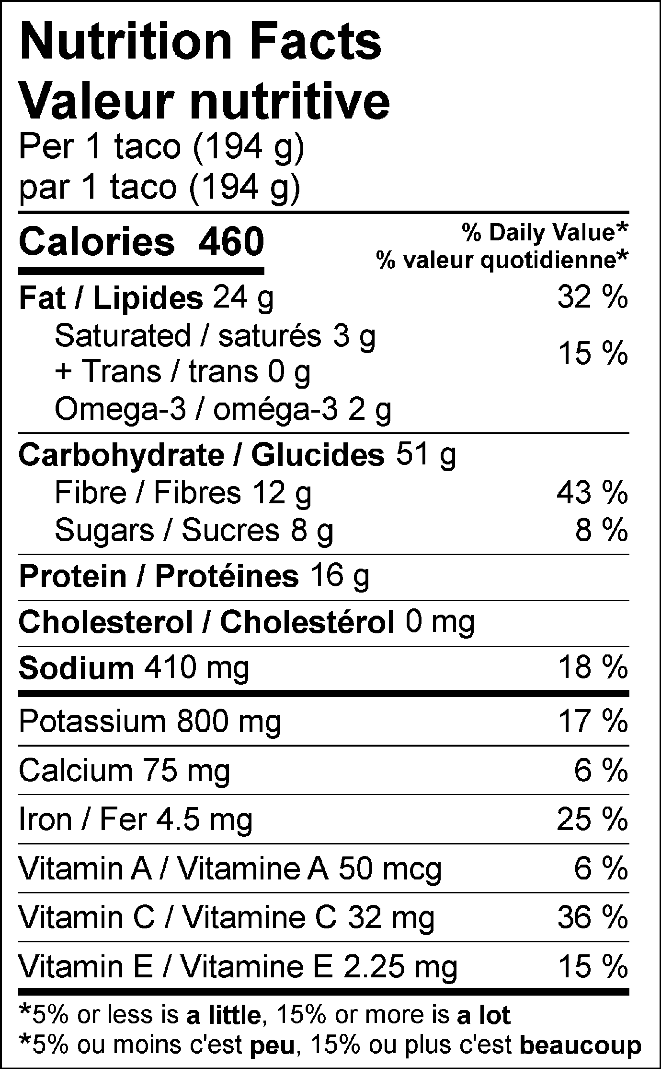

Intro: If I had to choose a menu consisting of my last meals on earth, tacos would make the short list, particularly this super simple recipe. The stodgy, substantial texture of lentils and walnuts combined with all the necessary seasonings for the perfect taco topped off with a sweet, tangy and creamy salsa makes for a happy mouth. Bring this recipe out for all commemorative occasions: Taco Tuesdays with the family, that soccer team victory party or when you just simply receive some good news. Consequently, you can brag that one taco provides 12g of fibre, 16g of protein and 25% of your daily iron needs in addition to the phytonutrients and antioxidants present in every head tilting bite.

Symbols: high source of fibre, good for bowel motility, high protein, kid friendly, good for all seasons, soy free, make ahead meals

Functional foods present: legumes (lentils), allium vegetables (onions, garlic), dried herbs, orange fruit (mango), leafy greens (cilantro), healthy fats (avocado), citrus fruit (lime)

Examples of phytonutrients and anti-oxidants present: polyphenols (legumes), allicin (onions, garlic), carotenoids (orange fruits, leafy greens, dried herbs), vitamin E (avocado), vitamin C (citrus fruit)

