2020 CAPO Conference: Poster Presenter Instructions

Poster Presenters Instructions

Poster presentations will be presented on a virtual poster board. Poster file dimensions should be (template attached):

Please submit a poster with the following dimensions: 1920 pixels x 1080 pixels (20" x 11.25") in PDF. Feel free to get creative with your poster. You can add motion and create a video poster where you can have moving images on the screen. For your poster presentation, you can also divide your poster into quarters, to provide zoomed-in close-ups of your poster that can be rotated while you speak.

SLIDE 1 is mandatory and must be a full summary of your poster, any additional slides are simply sections of the poster and are optional, not required.

Slide 1 - Final poster
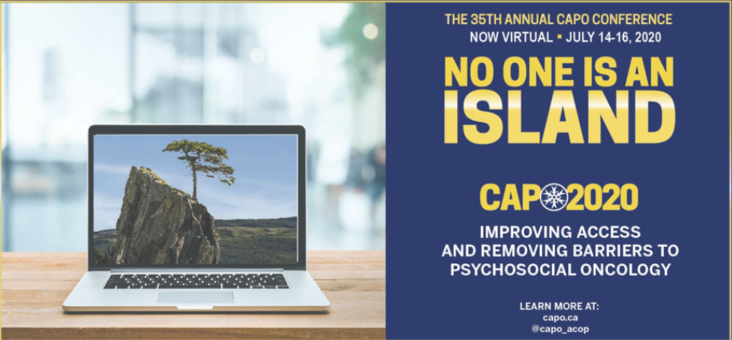
Slide 2 Slide 3 Slide 4 Slide 5

All poster presenters will be given the opportunity to record a short video (2-3 minutes) that will accompany your virtual poster. Instructions on best practices for recording a video are attached (HOW TO: Present and Record). This document also provides options of platforms available for recording.

Posters will be visible to conference registrants in advance of and throughout the conference proceedings. A scheduled live poster session is also included in the program. We encourage presenters to be available for live chat with participants during this timeframe.

Presenters are requested to send electronically your poster file and recording of your poster presentation by no later than June 22, 2020 allowing time for us to edit and program presentations into the conference platform. We encourage you to submit your presentations as early as possible, June 22 is the absolute cut-off date.

Instructions appear below.
- Please record your poster presentation with your video recording via zoom.
- Please use the attached graphic for your Zoom Virtual Background. Instructions on how to use this background can be found here How to use a Virtual Background
- Once you begin recording a video it automatically saves it as an mp4 or mov. file.
HOW TO: Submit & Upload your presentation
Note: All poster presenters must submit their PowerPoint presentations electronically by no later than the date stated above (by presentation type).

The CAPO Conference uses File Request Pro to collect and receive all files and presentations.
Please use the link provided below.
- Use the link provided "https://filerequestpro.com/up/poster-presentation"
- Drag your files into the upload area. You can drag multiple files (video, documents etc.) at once.
- Then fill out your abstract id #, first and last name and hit "send files". Once the upload is complete, you can close the window.
- The files are stored in File Request Pro, but are also sent to our Google Drive automatically.
- A folder is automatically created with your name inside the respective panel folder.

HOW TO: Name your submission materials

Please use the below naming conventions to name all of your materials (PowerPoint presentation, video, poster, documents etc.) Once your recording and/or PowerPoint presentation is ready you will need to save it with your assigned Abstract number and your first and last name.

Example:
If your information is: Your saved file name would be:
Abstract Number: 23 23_Stan_Smith.pptx
First name: Stan 23_Stan_Smith.mov
Last Name: Smith

Please do not add any other characters when naming, it must begin with a pure number for sorting and programming purposes.

If you experience any difficulties uploading your files please contact web@capo.ca for further assistance.

Resources
● Creative ways to film yourself
● Quality Video from your smartphone
- How to Share your screen
- How to use a Virtual Background

SAVE YOUR FILES HERE:

Upload Link: https://filerequestpro.com/up/poster-presentation

